1. Logo.

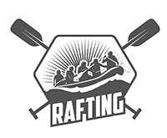

1. Write out the four (4) color labels (listed below) with the color codes you selected:
   1. primary-color 354F52 ~ Dark slate gray
   2. secondary-color CAD2C5 ~ Ash gray
   3. accent1-color 84A98C ~ Cambridge blue
   4. accent2-color 52796F ~ Hooker's green
2. Write out the two (2) font labels (listed below) and the names of the fonts you selected:
   1. heading-font: **Inter -** This font will be used for headings (titles, subtitles)
   2. text-font: Open Sans - This font will be used for the body text.
3. Color pallete URL

https://coolors.co/palette/cad2c5-84a98c-52796f-354f52-2f3e46